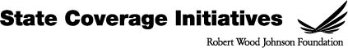

Words to Avoid | Words to Use
Universal health care | Quality, affordable health care
Canadian Style Health care | American solutions
Medicare for All | A choice of private and public plans
Competition | Choice and control
Government health care for all | Giving security and peace of mind
Regulations | Fair rules
Free | Sliding scale, pay what you can afford
Wellness | Prevention
Required | Guaranteed
Public or Government health care | Government as a watchdog, ensure a fair playing field
Basic health care | Affordable health plans
Inexpensive | Smart investments, investing in the future

