

Communications Plan Blueprint

Goal(s)

A goal is a long-term outcome to which all of your agency’s work is directed and which all of your objectives, strategies and tactics are designed to support. If asked to describe your agency’s most important overall goal in one to two sentences what would it be?


Objectives

Objectives are big-picture yet time-limited and measurable steps toward the achievement of your overall goal. Objectives should be outlined to support each of your individual goals.

Remember: objectives are specific, measurable, achievable and controllable

What are the main objectives you want to accomplish over the next year that will bring you closer to reaching your goal?

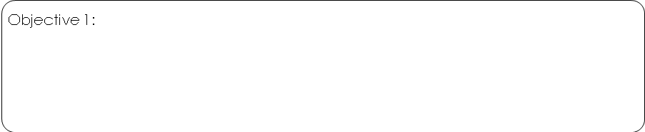
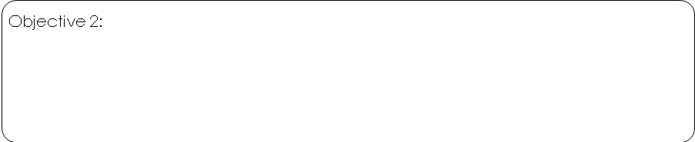
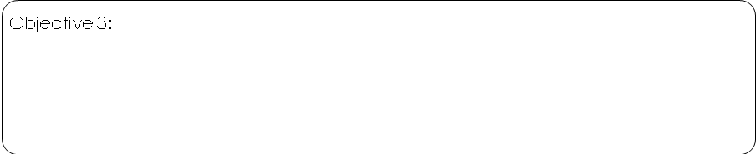
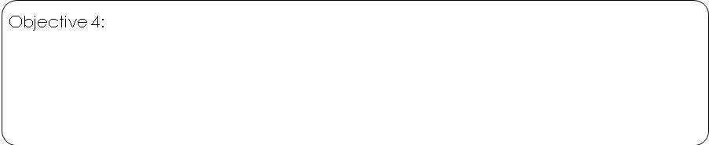

Target Audiences

Your primary target audience is the group of people you are ultimately trying to reach with your message. Secondary target audiences are those who you want to reach because they can help influence your primary audience.

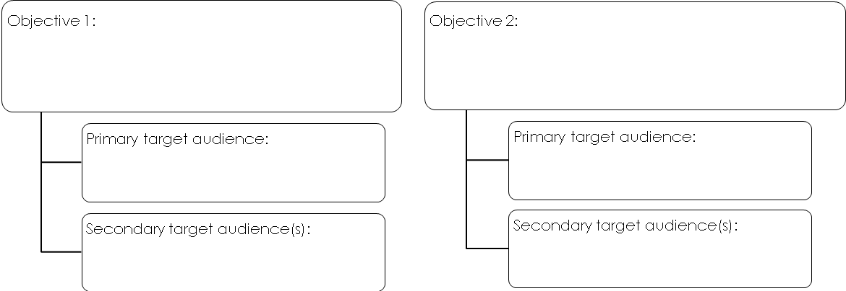
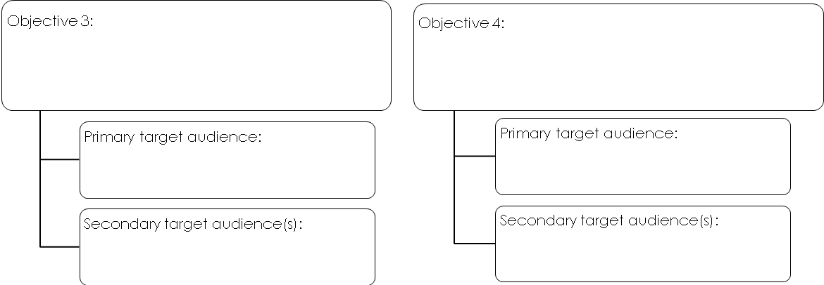

Strategies

Strategies are general categories of action that define how you will achieve your goals and objectives and provide a framework within which specific tactics should operate. Examples include:
- Use the media selectively to reach target audiences
- Tie-in with established organizations to create a halo effect
- Partner with credentialed third-party experts

What general approaches will you take to reach each of your objectives?
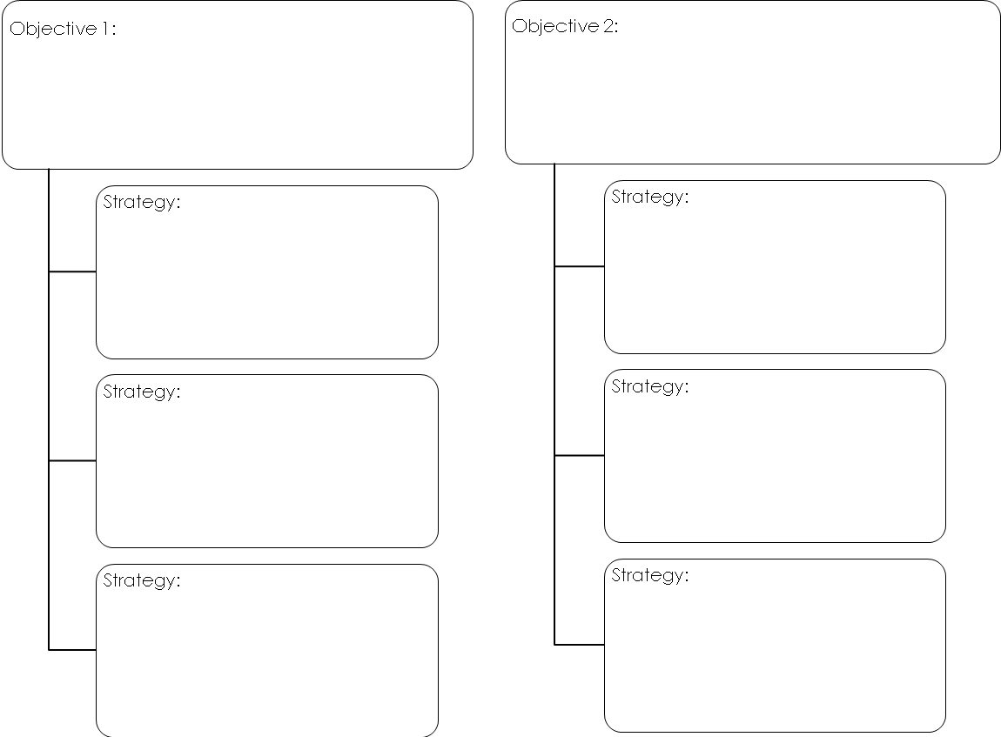

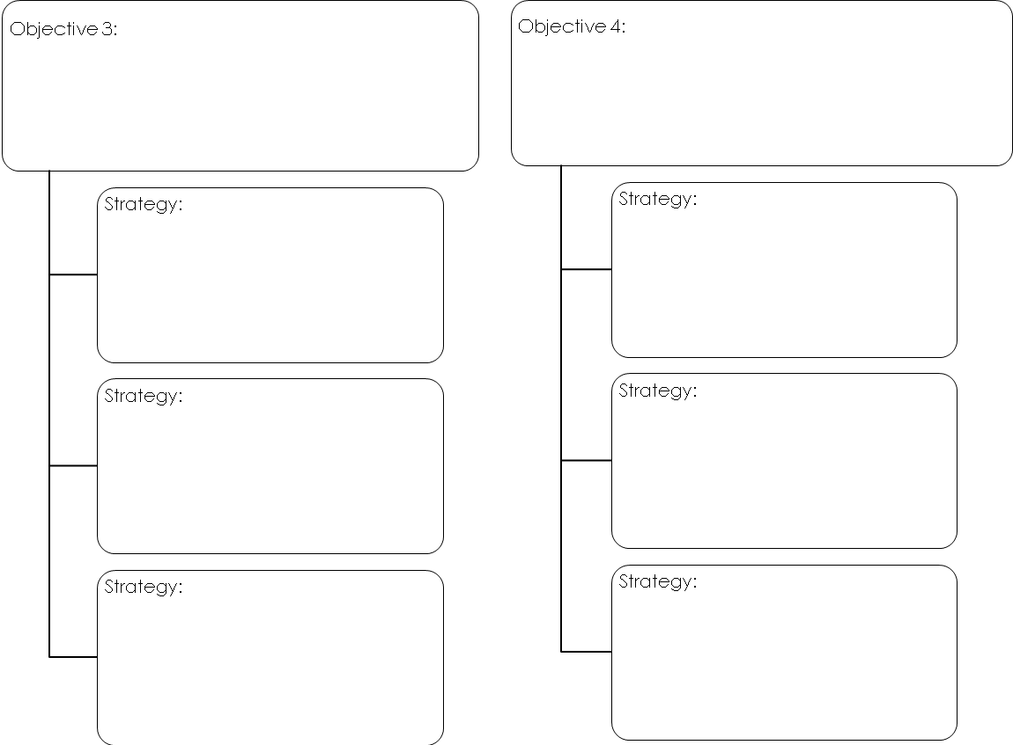

Core Messages

Effective communications efforts are rooted in core messages that are simple, compelling and specifically tailored to appeal to your target audience(s) and move them to action.
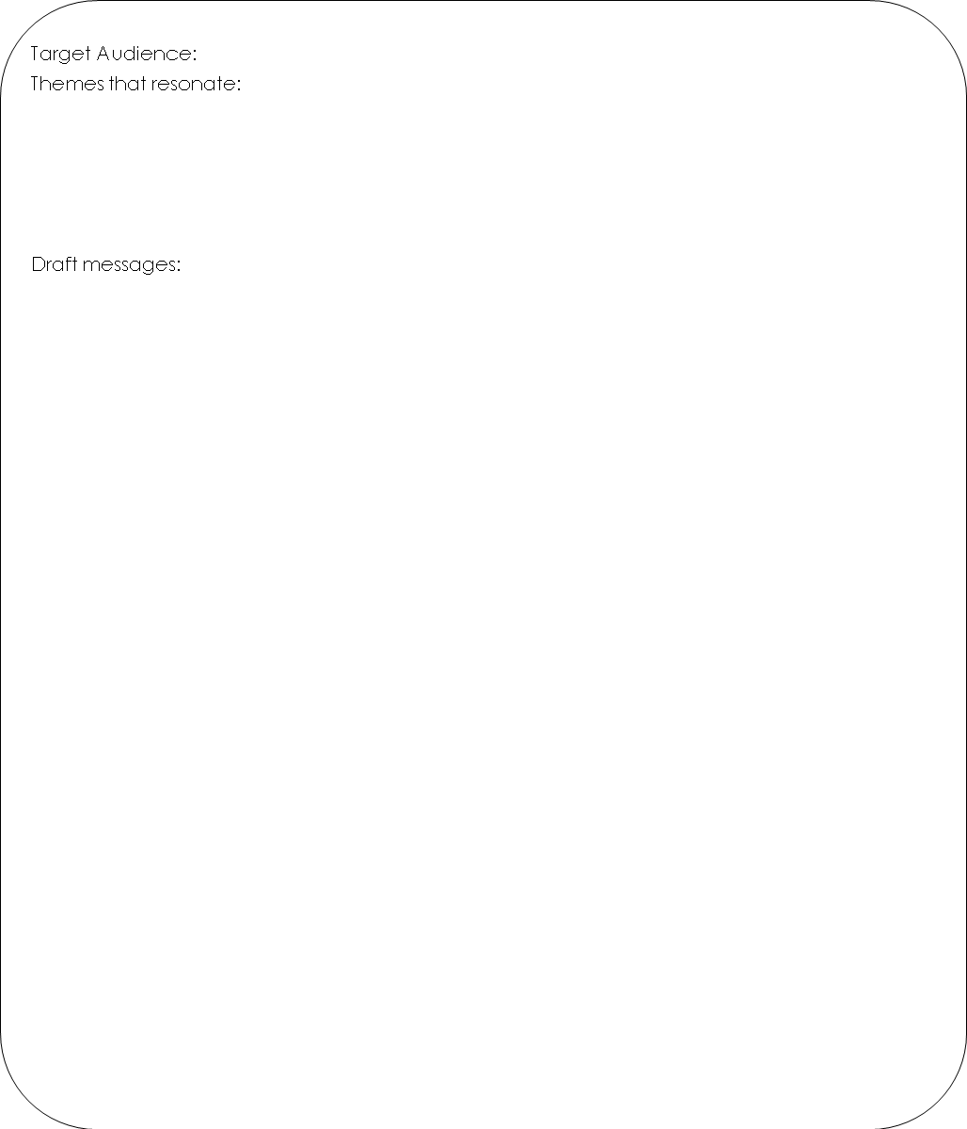
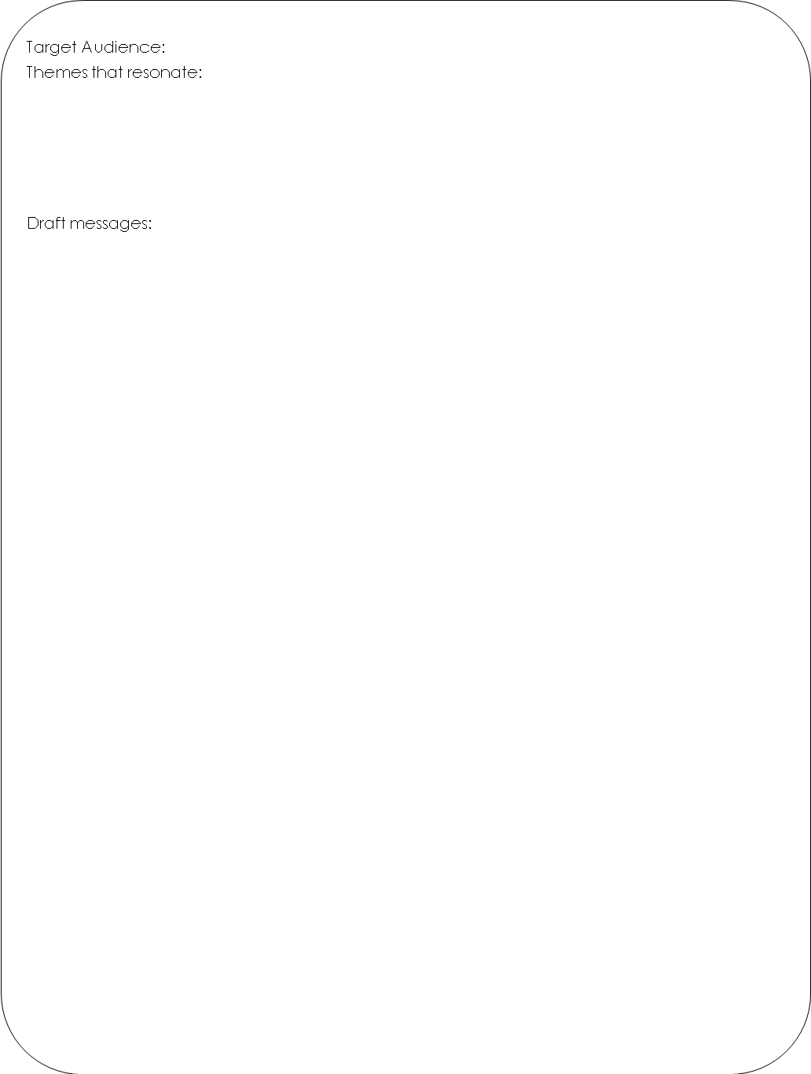
Tactics

Tactics are the specific, assignable actions you will take to achieve your objectives. Tactics could include: earned media outreach (press releases, media events, op-ed, letters to the editor, speakers’ bureau); events (annual conference, meetings; distribution of promotional materials (brochures, one-pagers, reports, newsletters); stakeholder outreach (one-on-one meetings, partnership development, etc.); paid media (TV, print, online advertising); Web Tools (website, blog, listserv, chat board, etc.) and more.

